Chapter 1
Simple Mechanism

Kinematics. It is that branch of Theory of Machines which deals with the relative motion between the various parts of the machines.

Dynamics. It is that branch of Theory of Machines which deals with the forces and their effects, while acting upon the machine parts in motion.

Kinetics. It is that branch of Theory of Machines which deals with the inertia forces which arise from the combined effect of the mass and motion of the machine parts.

Statics. It is that branch of Theory of Machines which deals with the forces and their effects while the machine parts are at rest. The mass of the parts is assumed to be negligible.

Kinematic Link or Element
Each part of a machine, which moves relative to some other part, is known as a kinematic link (or simply link) or element.

Types of Links
In order to transmit motion, the driver and the follower may be connected by the following three types of links :

- Rigid link. A rigid link is one which does not undergo any deformation while transmitting
motion. Strictly speaking, rigid links do not exist. However, as the deformation of a connecting rod, crank etc. of a reciprocating steam engine is not appreciable, they can be considered as rigid links.

- Flexible link. A flexible link is one which is partly deformed in a manner not to affect the transmission of motion. For example, belts, ropes, chains and wires are flexible links and transmit tensile forces only.

- Fluid link. A fluid link is one which is formed by having a fluid in a receptacle and the motion is transmitted through the fluid by pressure or compression only, as in the case of hydraulic presses, jacks and brakes.

Difference Between a Machine and a Structure
The following differences between a machine and a structure are important from the subject point of view:
- The parts of a machine move relative to one another, whereas the members of a structure do not move relative to one another.
- A machine transforms the available energy into some useful work, whereas in a structure no energy is transformed into useful work.
- The links of a machine may transmit both power and motion, while the members of a structure transmit forces only.

Types of Constrained Motions
The motion which takes place in a definite direction is called constrained motion
Following are the three types of constrained motions:
- Completely constrained motion. When the motion between a pair is limited to a definite direction irrespective of the direction of force applied, then the motion is said to be a completely constrained motion. For example, the piston and cylinder (in a steam engine) form a pair and the motion of the piston is limited to a definite direction (i.e. it will only reciprocate) relative to the cylinder irrespective of the direction of motion of the crank

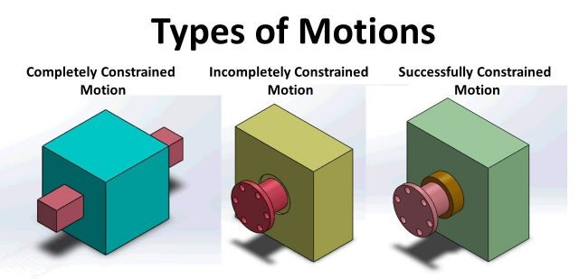

- Incompletely constrained motion. When the motion between a pair can take place in more than one direction, then the motion is called an incompletely constrained motion. The change in the direction of impressed force may alter the direction of relative motion between the pair.
- Successfully constrained motion. When the motion between the elements, forming a pair, is such that the constrained motion is not completed by itself, but by some other means, then the motion is said to be successfully constrained motion

Link: https://www.youtube.com/watch?v=RMBsBRWX7QE

Kinematic Pair
The two links or elements of a machine, when in contact with each other, are said to form a pair. If the relative motion between them is completely or successfully constrained (i.e. in a definite direction), the pair is known as kinematic pair

Classification of Kinematic Pairs
The kinematic pairs may be classified according to the following considerations:
- According to the type of relative motion between the elements. The kinematic pairs according to type of relative motion between the elements may be classified as discussed below:
  - Sliding pair. When the two elements of a pair are connected in such a way that one can only slide relative to the other, the pair is known as a sliding pair. The piston and cylinder, cross-head and guides of a reciprocating steam engine, ram and its guides in shaper, tail stock on the lathe bed etc. are the examples of a sliding pair. A little consideration will show, that a sliding pair has a completely constrained motion.
  - Turning pair. When the two elements of a pair are connected in such a way that one can only turn or revolve about a fixed axis of another link, the pair is known as turning pair. A shaft with collars at both ends fitted into a circular hole, the crankshaft in a journal bearing in an engine, lathe spindle supported in head stock, cycle wheels turning over their axles etc. are the examples of a turning pair. A turning pair also has a completely constrained motion.
  - Rolling pair. When the two elements of a pair are connected in such a way that one rolls over another fixed link, the pair is known as rolling pair. Ball and roller bearings are examples of rolling pair.
  - Screw pair. When the two elements of a pair are connected in such a way that one element can turn about the other by screw threads, the pair is known as screw pair. The lead screw of a lathe with nut, and bolt with a nut are examples of a screw pair.
  - Spherical pair. When the two elements of a pair are connected in such a way that one element (with spherical shape) turns or swivels about the other fixed element, the pair formed is called a spherical pair. The ball and socket joint, attachment of a car mirror, pen stand etc., are the examples of a spherical pair.

- According to the type of contact between the elements. The kinematic pairs according to the type of contact between the elements may be classified as discussed below :
  - Lower pair. When the two elements of a pair have a surface contact when relative motion takes place and the surface of one element slides over the surface of the other, the pair formed ism known as lower pair. It will be seen that sliding pairs, turning pairs and screw pairs form lower pairs.
  - Higher pair. When the two elements of a pair have a line or point contact when relative motion takes place and the motion between the two elements is partly turning and partly sliding,then the pair is known as higher pair. A pair of friction discs, toothed gearing, belt and rope drives, ball and roller bearings and cam and follower are the examples of higher pairs.
- According to the type of closure. The kinematic pairs according to the type of closure between the elements may be classified as discussed below :
  - Self closed pair. When the two elements of a pair are connected together mechanically in such a way that only required kind of relative motion occurs, it is then known as self closed pair. The lower pairs are self closed pair.
  - Force - closed pair. When the two elements of a pair are not connected mechanically but are kept in contact by the action of external forces, the pair is said to be a force-closed pair. The cam and follower is an example of force closed pair, as it is kept in contact by the forces exerted by spring and gravity.

Link: https://www.youtube.com/watch?v=cU1PLmkjwIg

Kinematic Chain
When the kinematic pairs are coupled in such a way that the last link is joined to the first link to transmit definite motion (i.e. completely or successfully constrained motion), it is called a kinematic chain

Mechanism
When one of the links of a kinematic chain is fixed, the chain is known as mechanism. A mechanism with four links is known as simple mechanism, and the mechanism with more than four links is known as compound mechanism. When a mechanism is required to transmit power or to do some particular type of work, it then becomes a machine

Inversion of Mechanism
The method of obtaining different mechanisms by fixing different links in a kinematic chain, is known as inversion of the mechanism.

Types of Kinematic Chains
The most important kinematic chains are those which consist of four lower pairs, each pair being a sliding pair or a turning pair. The following three types of kinematic chains with four lower pairs are important from the subject point of view:

- Four bar chain or quadric cyclic chain,
- Single slider crank chain, and
- Double slider crank chain.

Four Bar Chain or Quadric Cycle Chain
It is made of four rigid links which are connected to form a quadrilateral by four pin joints.

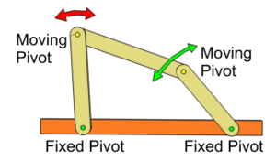

Links: https://www.youtube.com/watch?v=KBFFwgCCP0U&feature=youtu.be
https://www.youtube.com/watch?v=0neC37jBxQw&feature=youtu.be
https://www.youtube.com/watch?v=uvJjFgRqSTg&feature=youtu.be

Inversions of Four Bar Chain
- Coupling rod of a locomotive (Double crank mechanism). The mechanism of a coupling rod of a locomotive (also known as double crank mechanism) which consists of four links, In this mechanism, the links AD and BC (having equal length) act as cranks and are connected to the respective wheels. The link CD acts as a coupling rod and the link AB is fixed in order to maintain a constant centre to centre distance between them. This mechanism is meant for transmitting rotary motion from one wheel to the other wheel.

Link: https://www.youtube.com/watch?v=gYmT1M4NyyM&feature=youtu.be
https://www.youtube.com/watch?v=8yRVMnPJmdQ
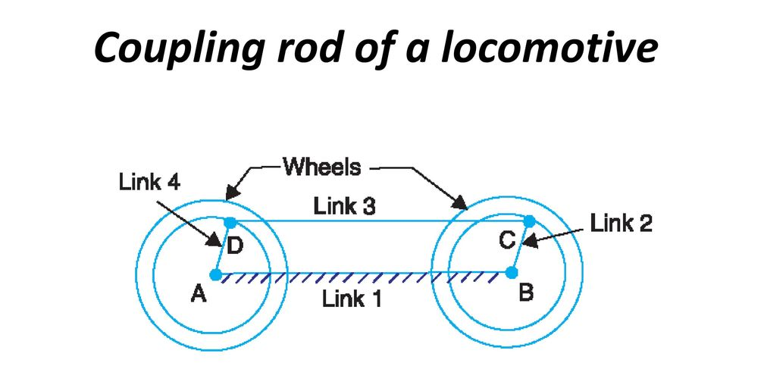
- Pantograph. It is an instrument which duplicates motion exactly, but to a reduced or enlarged scale.

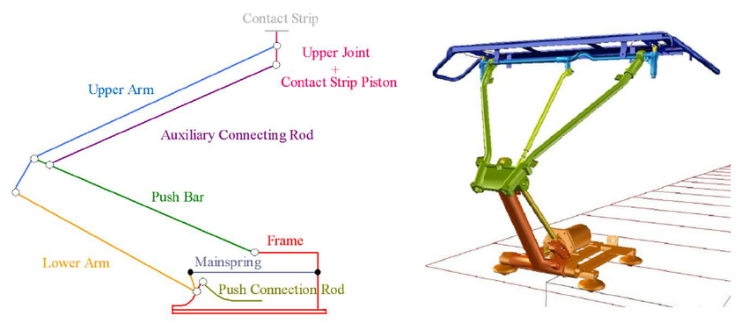
Link: https://www.youtube.com/watch?v=76WDPNMbsLc

Single Slider Crank Chain
A single slider crank chain is a modification of the basic four bar chain. It consist of one sliding pair and three turning pairs.

Inversions of Single Slider Crank Chain
- Rotary internal combustion engine or Gnome engine. Sometimes back, rotary internal combustion engines were used in aviation. But now-a-days gas turbines are used in its place. It consists of seven cylinders in one plane and all revolves about fixed centre D, while the crank (link 2) is fixed. In this mechanism, when the connecting rod (link 4) rotates, the piston (link 3) reciprocates inside the cylinders forming link 1.

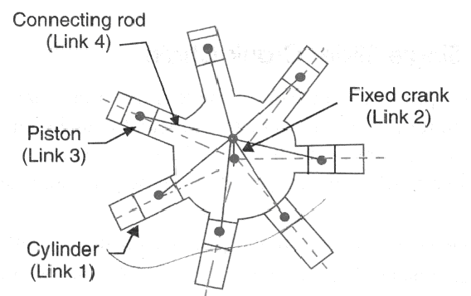

- Crank and slotted lever quick return motion mechanism. This mechanism is mostly used in shaping machines, slotting machines and in rotary internal combustion engines.
In this mechanism, the link AC (i.e. link 3) forming the turning pair is fixed, The link 3 corresponds to the connecting rod of a reciprocating steam engine. The driving crank CB revolves with uniform angular speed about the fixed centre C. A sliding block attached to the crank pin at B slides along the slotted bar AP and thus causes AP to oscillate about the pivoted point A. A short link PR transmits the motion from AP to the ram which carries the tool and reciprocates along the line of stroke R1 R2. The line of stroke of the ram (i.e. R1 R2) is perpendicular to AC produced.

Link: https://www.youtube.com/watch?v=ESBYdJx8X7k&feature=youtu.be
https://www.youtube.com/watch?v=s3TiMedJKds&feature=youtu.be
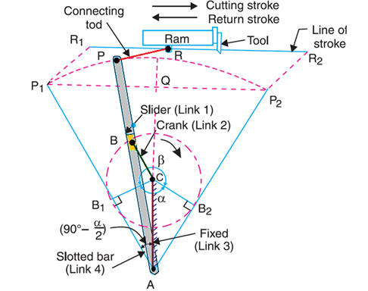

Double Slider Crank Chain
A kinematic chain which consists of two turning pairs and two sliding pairs is known as double slider crank chain.

- Scotch yoke mechanism. This mechanism is used for converting rotary motion into a reciprocating motion. The inversion is obtained by fixing either the link 1 or link 3. Link 1 is fixed. In this mechanism, when the link 2 (which corresponds to crank) rotates about B as centre, the link 4 (which corresponds to a frame) reciprocates. The fixed link 1 guides the frame.

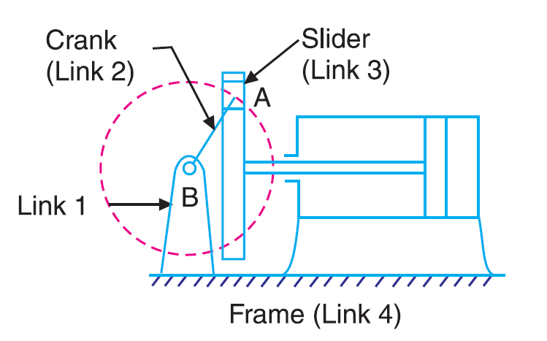

- Oldham’s coupling. An oldham's coupling is used for connecting two parallel shafts whose axes are at a small distance apart. The shafts are coupled in such a way that if one shaft rotates, the other shaft also rotates at the same speed.
